Worksheet 1
Harry Stevens: Why outbreaks like coronavirus spread exponentially
Scenario 1: Free-for-all
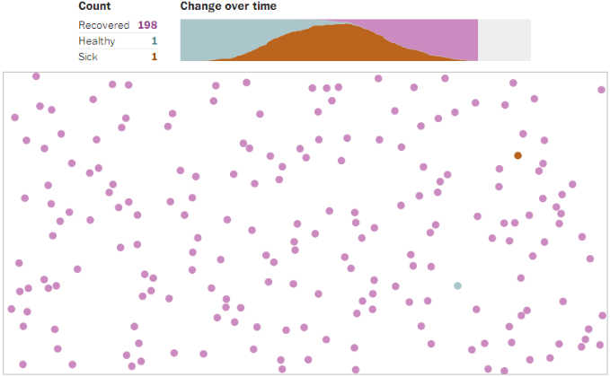
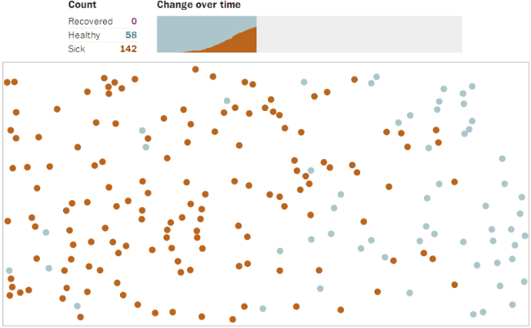
Description:

Scenario 2: Attempted quarantine
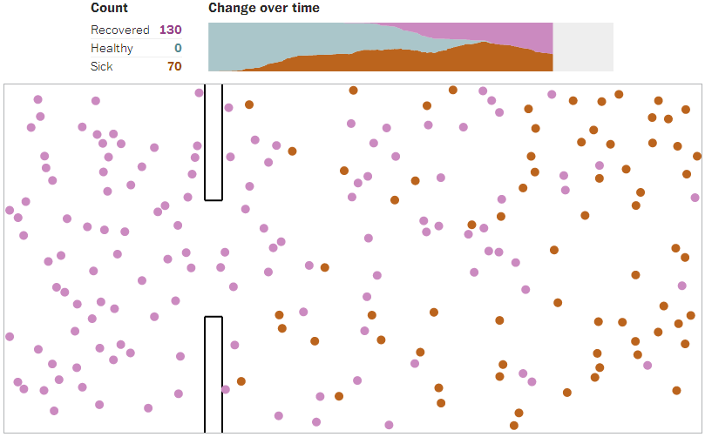
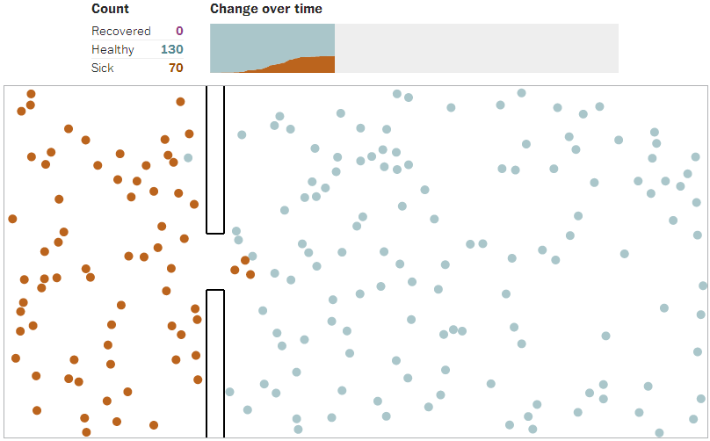
Description:

Worksheet 2
Harry Stevens: Why outbreaks like coronavirus spread exponentially
Scenario 3: Moderate distancing
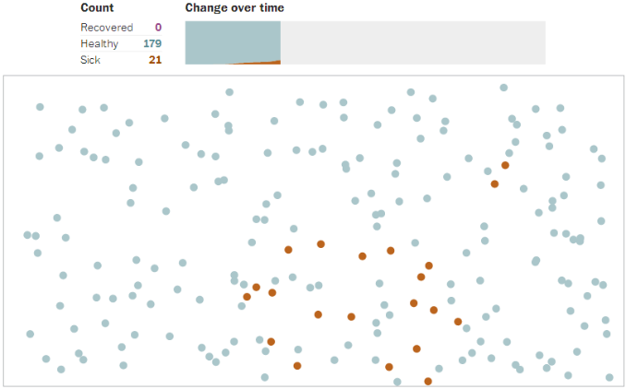
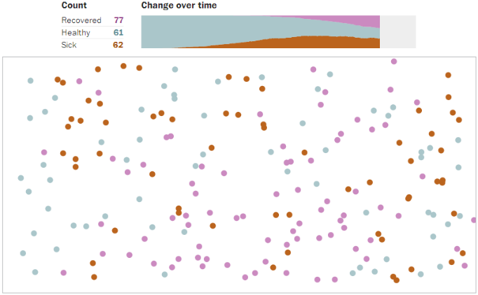

Description:

Scenario 4: Extensive distancing
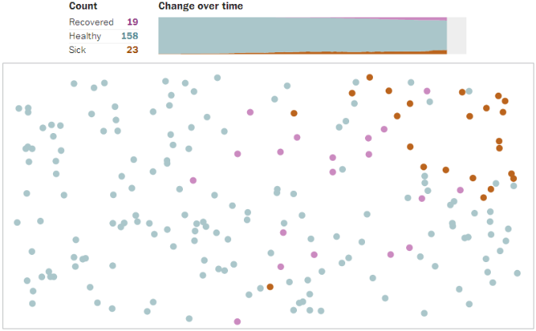
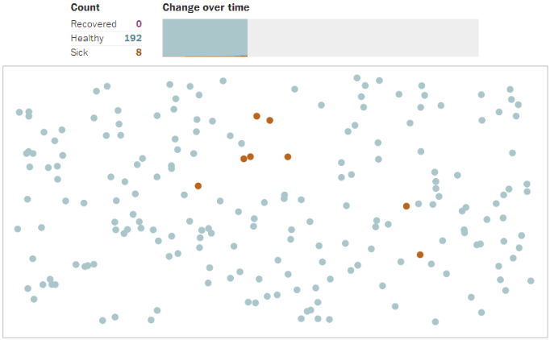

Description:

Worksheet 3
Harry Stevens: Why outbreaks like coronavirus spread exponentially

Alfred Nordmann: Do you all just want to be little dots? [Excerpt]

What else are we? Since Corona has had a grip on the world, we are a cluster of little dots. They wander around in space and collide randomly with other dots. At least, that‘s how a graphic from the Washington Post depicts it. One of these dots is infected with the virus and passes on the infection with each collision. At exponential lightning speed, the disease is spreading, and soon it has taken over the entire population. If only the movement of the dots is restricted, the infection rate can be brought under control. So impressive, so convincing. And yet disconcerting.
The fact that stores and restaurants are closed and people have to avoid contact already seems to make a difference. That‘s why a decision is to be made soon on how to proceed. This is a political decision based on knowledge and science. This includes the current tone-setting knowledge about the small dots that define each of us as a risk that needs to be contained.
Do we really recognise ourselves in this? Are we nothing more than blindly acting particles, seemingly moving through life without rhyme or reason, observed from the bird‘s eye view of a government art that seeks to protect and control the population as a whole? Perhaps there is some other knowledge that we citizens can bring into play. After all, we now understand the problem just as well as the epidemiologists and politicians, and perhaps we also have solutions to offer. [...]
It is often said that the restrictions on public life mean a loss of democracy. But this would not be due primarily to the self-importance of suddenly empowered politicians. Rather, it owes much more to the unrestricted validity of a science that reduces people to risk factors and must control the population. Now we should ask ourselves whether an epidemiology democratised by citizen science is possible. A disease control, in other words, that does not rule from above but mobilises our trained behaviours and alert inventiveness.
Do we have to accept, for example, that we are digitally monitored by an app in the name of health? Such an app should rather help users navigate self-responsibly through a world where coronavirus exists. It‘s not about relaxing strict measures too soon. But it is about managing risk together. We are a social and free country, economically strong, responsible, creative and digitised. Why don‘t we tackle this crisis in the same way – as a society that has a future?

Alfred Nordmann: Wollt ihr alle nur kleine Pünktchen sein?
© Zeit online, 04/12/2020 [excerpt, heavily abridged, translated by Frank U. Kugelmeier].
URL: https://www.zeit.de/wissen/2020-04/corona-pandemie-ausgangssperren-demokratie-staat-freiheit-alfred-nordmann/komplettansicht

For full analysis, please read the article in the original source (in German).

Author‘s note: Alfred Nordmann is a professor of philosophy of science and technology at Technical University of Darmstadt (Germany). He is also currently a visiting professor at the Technical Universities of St. Petersburg (SPbPU, Russia) and Guangzhou (SCUT, southern China).

